Lab Group #____

Observation Data Sheet

Object: _________________________

- Sketch the water drop’s profile view.
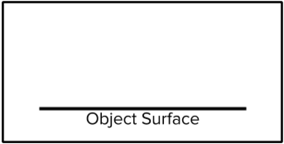
- Tilt Test
 The water drop slides when the surface is tilted at a ________ degree angle.
The water drop is absorbed and/or does not slide.

- Rate Surface Texture
Draw a large dot on the line to show where the object’s texture falls on your scale.

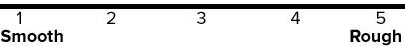
Lab Group #____

Observation Data Sheet

Object: _________________________

- Sketch the water drop’s profile view.
- Tilt Test
The water drop slides when the surface is tilted at a ________ degree angle.
The water drop is absorbed and/or does not slide.

- Rate Surface Texture
Draw a large dot on the line showing where the object’s texture falls on your scale.

